Working

A Fresh Air Unit is an HVAC (Heating, Ventilation, and Air Conditioning) system component that is designed to bring fresh outdoor air into a building's interior. Fresh Air Units are commonly used in commercial and residential buildings to improve indoor air quality by diluting and replacing the stagnant, potentially harmful air inside with fresh, oxygenated air from outside. Fresh Air Units can be designed in different configurations, such as standalone units or integrated into existing HVAC systems. They typically include a fan, filters to remove outdoor pollutants, and sometimes a heat exchanger to pre-condition the incoming air to minimize energy consumption. Fresh Air Units are especially important in buildings that are tightly sealed for energy efficiency, as these buildings may not have enough natural ventilation to bring in fresh air. By introducing fresh air into a building, Fresh Air Units can help reduce indoor air pollution, control humidity levels, and promote a healthier indoor environment.

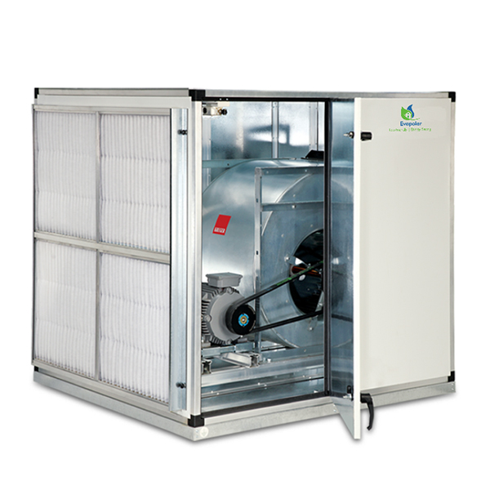

Data Attributes and its information

1. **ON/OFF CMD** – Command taken for the system it turn it on or off.
2. **A/M Status** – Working Mode of the System. Auto or Manual.
3. **Trip Status** – Refers to a fault or error condition that has caused the system to shut down or trip a safety switch. Trip is error occurred and Normal when system is working fine.
4. **Run Status** – Active running status of the system. On or Off.
5. **Schedule Mode** – Whether the system is scheduled or scheduling is off.
6. **Time Schedule** – Whether the Time Scheduling is on or off.

Addable Parameters

|  |  |  |
| --- | --- | --- |
| Name | Description | Range |
| Power Consumption | Monitoring the power consumption of the Treated Fresh Air Unit can provide insights into the system's efficiency and help predict maintenance needs. | For Window/Room AC –  Small : 0.5 to 0.7  Medium : 1 to 1.5  Large : 1.5 to 2.5 watts  For Split System AC –  Small : 0.6 to 0.9 kilowatts  Medium : 1.2 to 1.8 kilowatts  Large : 1.8 to 2.5 kilowatts |
| Fan Speed |  |  |
| Air Filter |  |  |
| Air Quality | Monitoring the status of the system's filters can help predict maintenance needs and ensure that the system is operating efficiently. | Clean and Dirty |
| Indoor Temperature | Monitoring the outdoor temperature can help predict the demand for heating or cooling and optimize the system's performance. | 15 -28 degree Celsius |
| Outdoor Temperature | Monitoring the airflow rates within the system can help ensure that the system is operating efficiently and help predict maintenance needs. | For Window/Room AC – In CFM  Small : 100 to 250  Medium : 250-400  Large : 400-500  For Split System AC –  Small : 100 to 300  Medium : 350-450  Large : 450-700 |
|  |  |  |
|  |  |  |
|  |  |  |

Example Dashboards

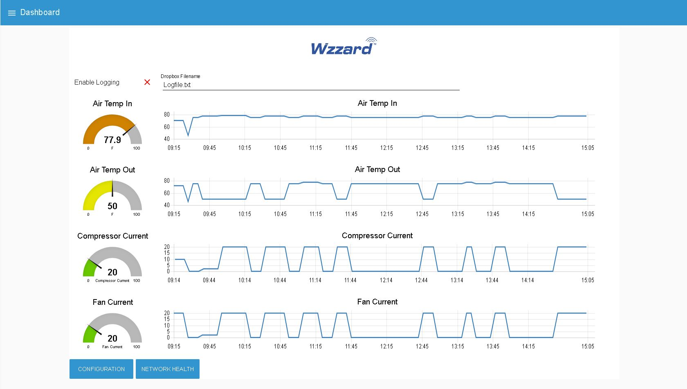

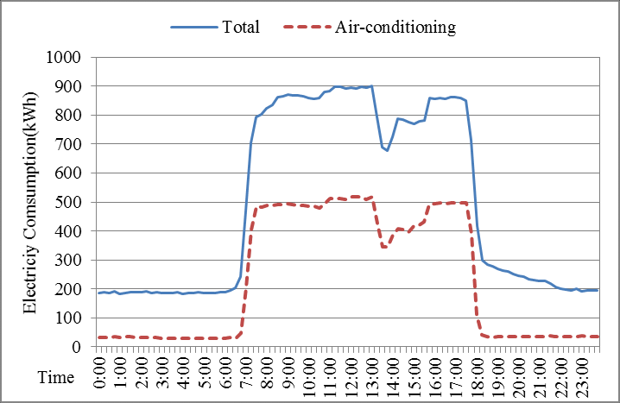

References

* <https://www.fabtechnologies.com/new-developments-in-treated-fresh-air-technology/#:~:text=Treated%20Fresh%20Air%20Units%20(TFA,degree%20using%20a%20cooling%20system>.
* <https://www.squareyards.com/mumbai-residential-property/phoenix-palladium/122206/project>
* <https://en.wikipedia.org/wiki/Phoenix_Marketcity_(Mumbai)>
* <https://en.wikipedia.org/wiki/High_Street_Phoenix>
* <https://en.wikipedia.org/wiki/Phoenix_Marketcity_(Bangalore)>
* <https://en.wikipedia.org/wiki/Phoenix_Marketcity_(Pune)>
* <https://lbb.in/chennai/palladium-mall-launch-chennai/>
* <https://www.thephoenixmills.com/businesses/retail>
* <https://en.wikipedia.org/wiki/Phoenix_Marketcity_(Chennai)>
* <https://www.phoenixpalassio.com/Mall-Map>
* <https://www.whatincity.com/listing/phoenix-united-mall-alambagh-lucknow/>
* <https://www.scai.in/portfolio/phoenix-united-mahanagar-colony-bareilly/>
* <https://noctua.at/en/productfaqs/productfaq/view/id/162/>
* <https://meersens.com/indoor-air-quality-the-impact-of-co2-on-health-and-wellbeing-at-work/?lang=en>
* <https://www.timeanddate.com/weather/india/new-delhi/climate>
* <https://www.daikin.com/products/ac/lineup/vrv#:~:text=The%20Daikin%20VRV%20system%20is,and%20floor%20of%20a%20building>.